Fast Nearest Neighbor Algorithms on a Linear Array with a Reconfigurable Pipelined Bus System

Yi Pan,Keqin Li, and Si-Qing Zheng
Parallel Algorithms and Application, Vol. 13, pp. 1-25 (1998)
- Introduction
Let A=(ai,j), 0≦i, j≦n-1, be a black and white n*n binary image in the form of a two-dimensional array, with each element ai,j being a pixel. Pixel ai,j is black if ai,j=1, and white if ai,j=0. In this paper, we consider solving the nearest neighbor problem on a linear array with a reconfigurable pipelined bus system (LARPBS).
- The LARPBS Model
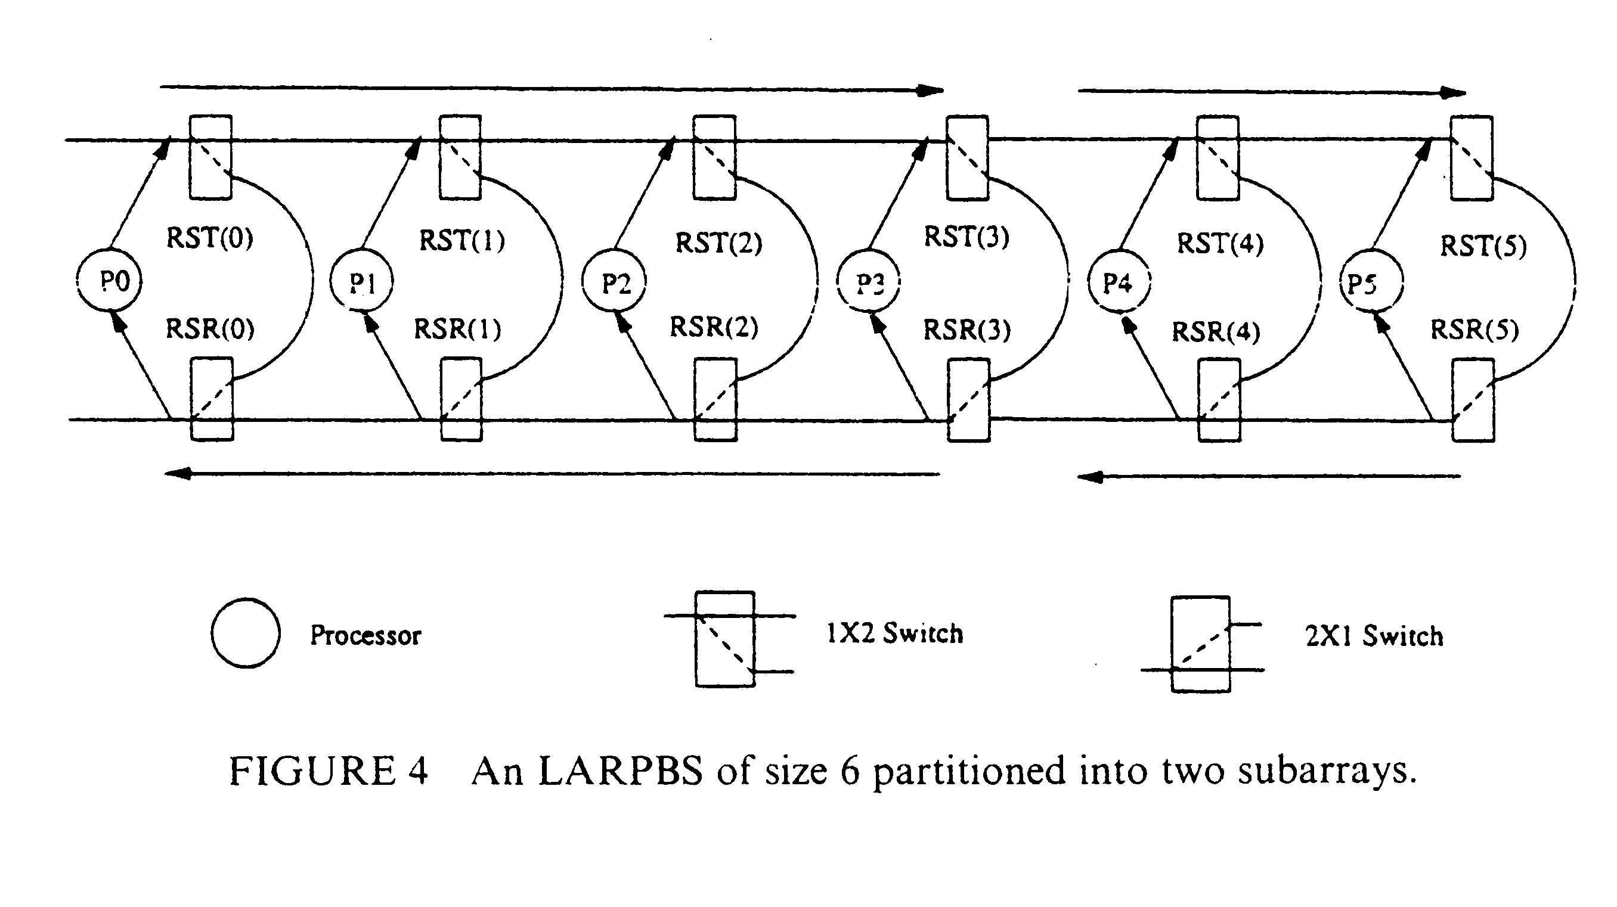
- Basic Operations
  - One-to-One Communication
tset(j)=tref + (N – j – 1)ω.
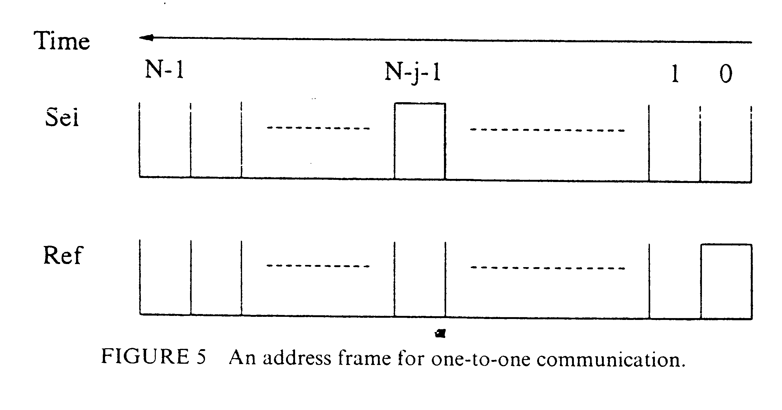
  - Broadcasting and Multicasting
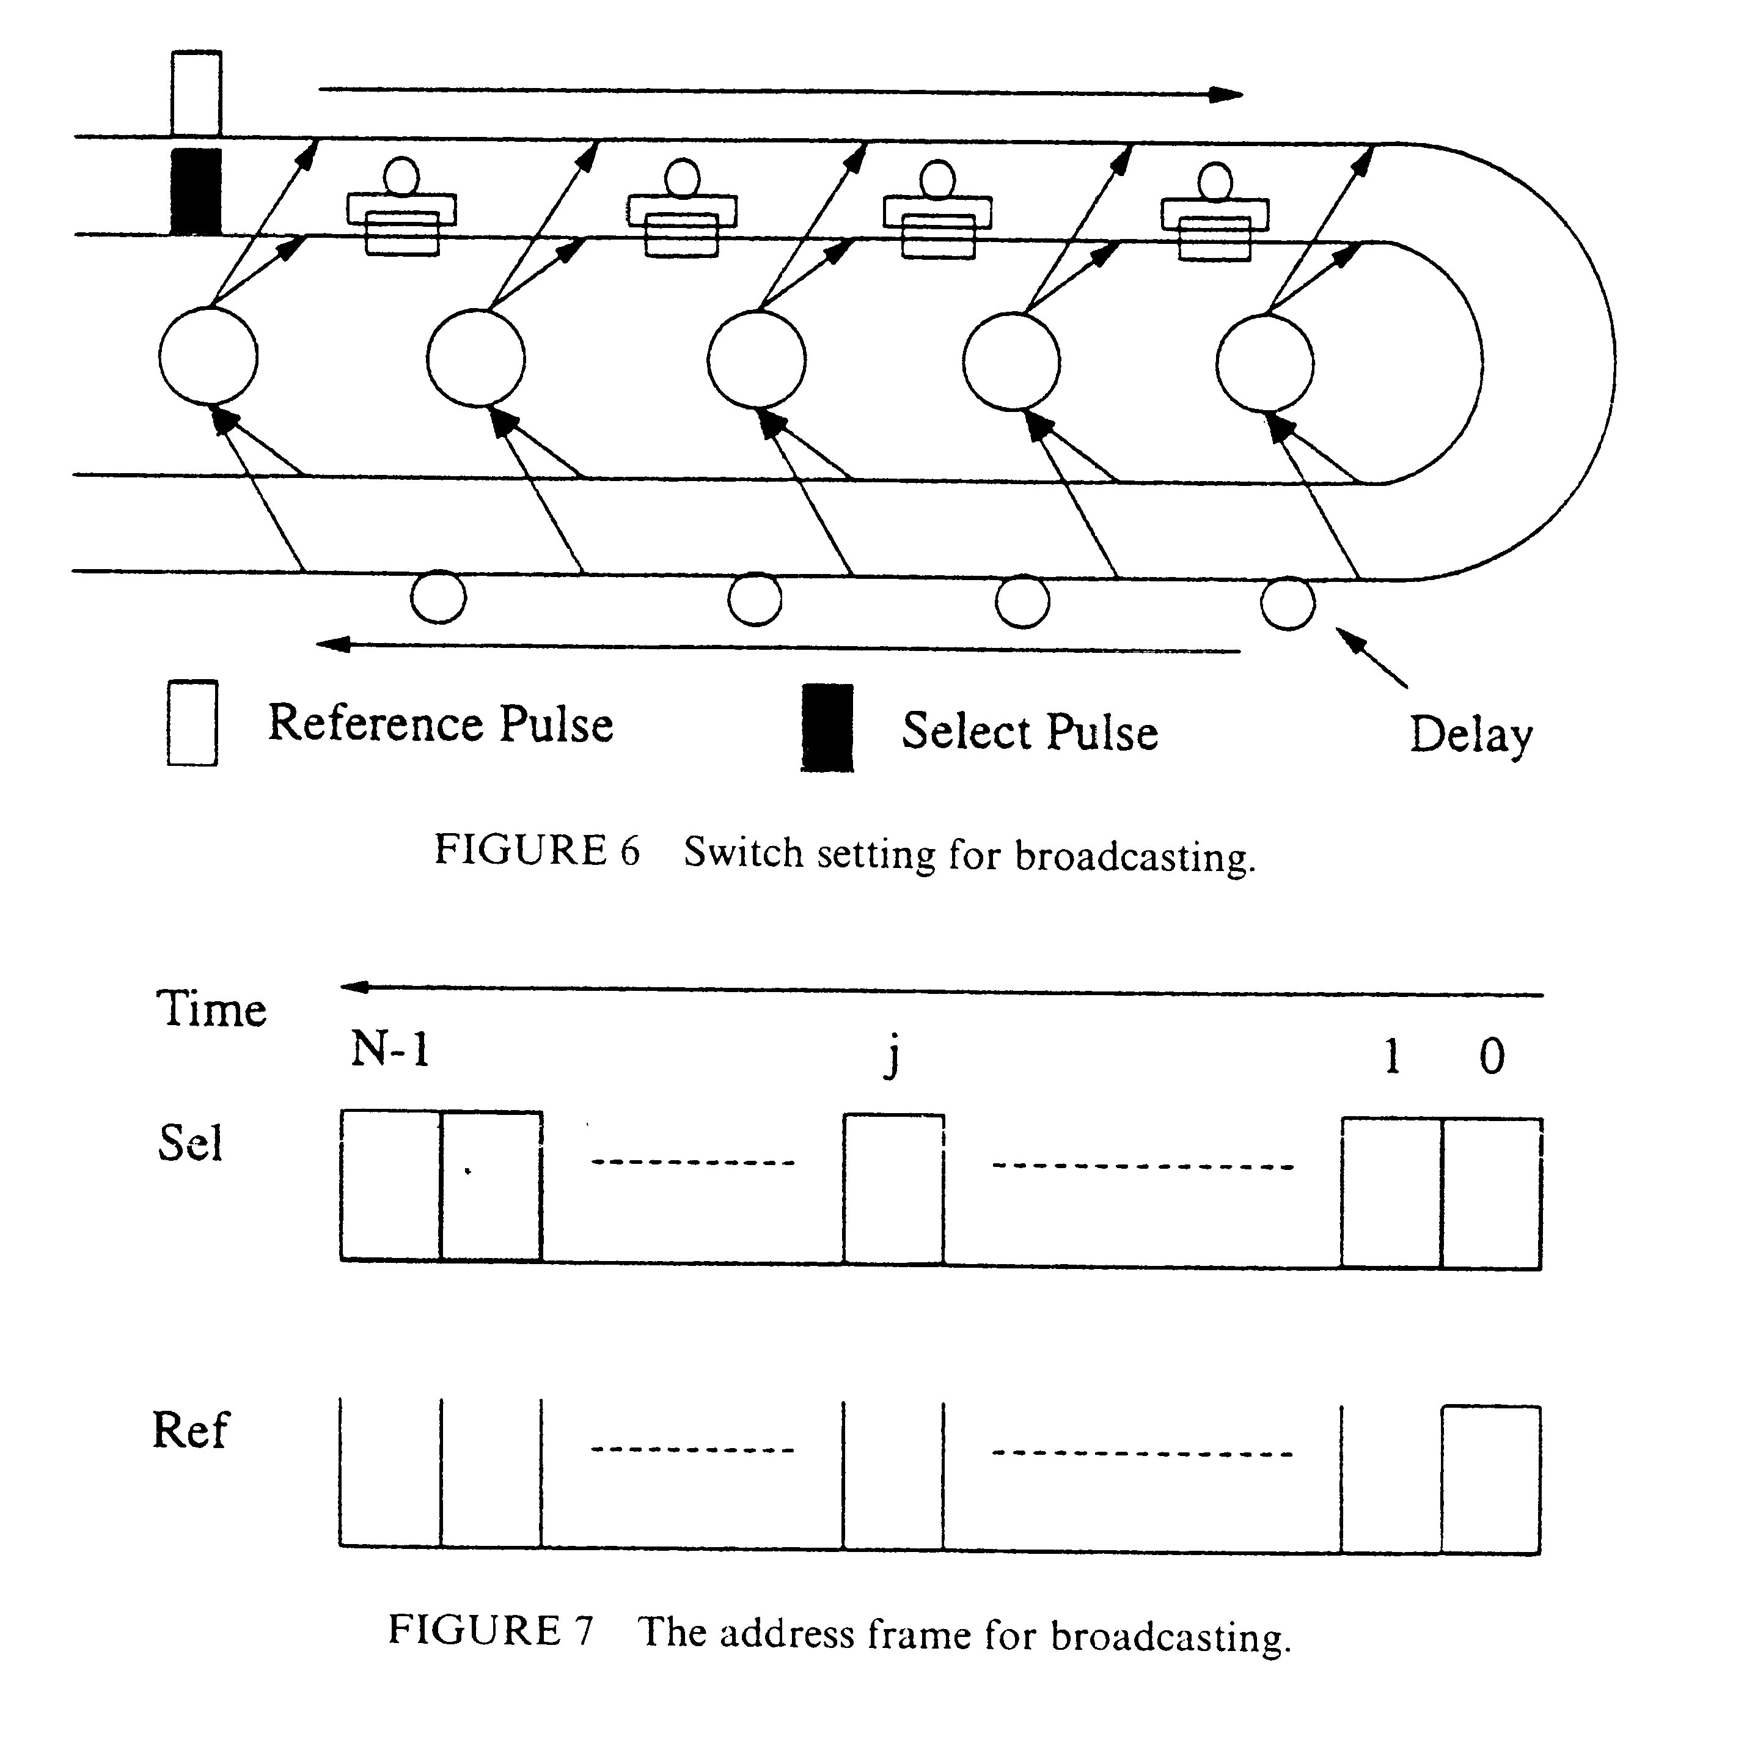
- Nearest Neighbor Algorithms
  - An Algorithm Framework
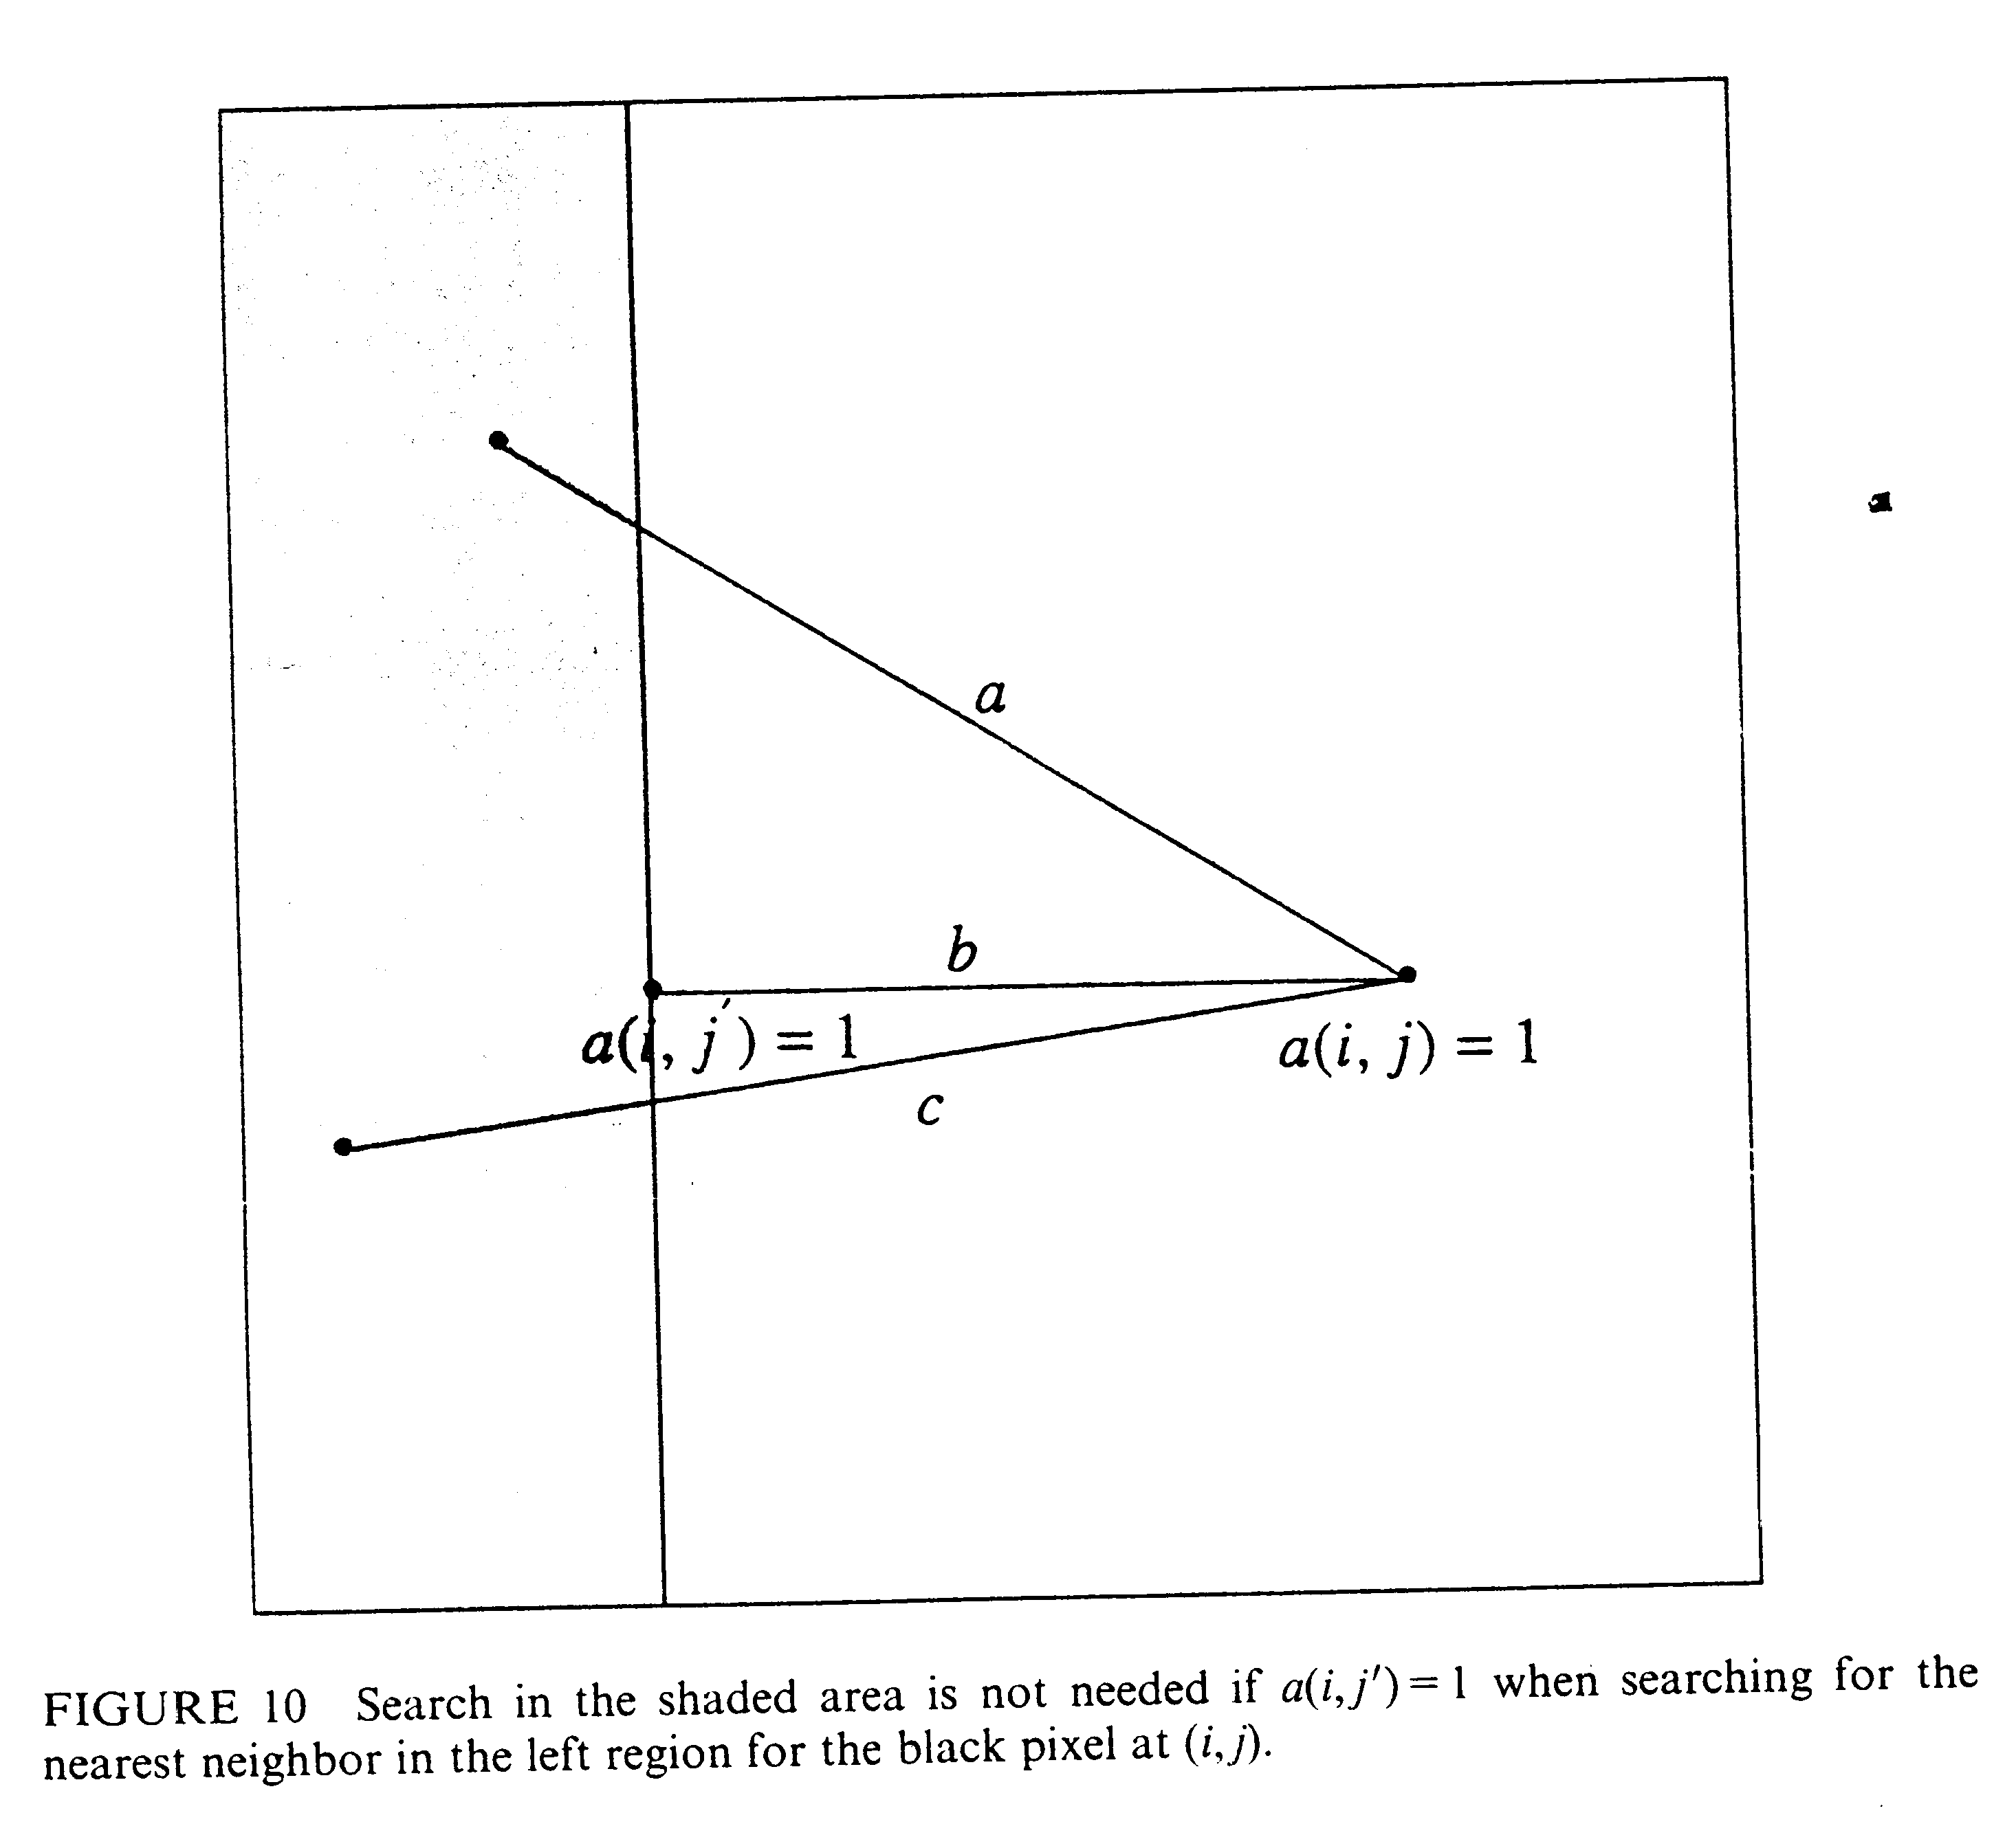

Eq. (1) : dist(ai,j, ai’,j')=((i-j’)^2+(j-j’)^2)^(1/2)
Step 1: For each pixel A(i,j), find j` such that A(i,j’) is the black pixel closest to A(i,j) to its right in row i, and store index pair(i,j’) in RIGHT_NEAREST(i,j). If such a pixel does not exist, let j’=∞.
Step 2: For each pixel A(i,j), find i’ such that A(i’,j) is the black pixel closest to A(i,j) from above in column j, and store index pair(i’,j) in UP_NEAREST(i,j). If such a pixel does not exist, let i’=∞.
Step 3: For each pixel A(i,j), find i” such that A(i”,j) is the black pixel closest to A(i,j) from below in column j, and store index pair(i”,j) in DOWN_NEAREST(i,j). If such a pixel does not exist, let i”=∞.
Step 4: For each PE(i,j) that originally stores a white pixel A(i,j), compute DISTup(i,j) and DISTdown(i,j) using Eq. (1), where DISTup(i,j) is the distance between pixel UP_NEAREST(i,j) and pixel RIGHT_NEAREST(i,j),and DISTdown(i,j) is the distance between pixel DOWN_NEAREST(i,j) and pixel RIGHT_NEAREST(i,j). Let DIST(i,j) := min{DISTup(i,j), DISTdown(i,j)}.
Step 5: For each PE(i,j) that originally stores a black pixel A(i,j), compute DISTup(i,j), DISTdown(i,j), DISTright(i,j) using Eq. (1), where DISTup(i,j) is the distance between pixel UP_NEAREST(i,j) and pixel A(i,j), DISTdown(i,j) is the distance between pixel DOWN_NEAREST(i,j) and pixel A(i,j), and DISTright(i,j) is the distance between pixel RIGHT_NEAREST(i,j) and pixel A(i,j).
Step 6: For each PE(i,j) that originally stores a black pixel A(i,j), send A(i,j) to processor PE(i,j’), where j”=RIGHT_NEAREST(i,j). For each PE(i,j’), if it receives a black pixel A(i,j), it stores the pair (i,j) in LEFT_NEAREST(i,j’); otherwise, it stores (i,∞) in LEFT_NEAREST(i,j’).
Step 7: For each PE(i,j) that originally stores a black pixel A(i,j), let DIST(i,j):=min{DISTup(i,j), DISTdown(i,j), DISTleft(i,j)}, where DISTleft(i,j) is the distance between A(i,j) and LEFT_NEAREST(i,j).
Step 8: Consider each row of the input image as several segments separated by black pixels. Each segment consists of a black pixel and the maximal number of consecutive white pixels immediately to its left. Let the PE that originally stores a black pixel be the leader of the segment. For each segment, find the minimum of the values DIST stored in the processors of the segment, and send the pixel with this DIST value to the leader of the segment.
  - An O(loglogn) Time Implementation
The task of finding the minimum of a set of N elements can be carried out in O(loglogN) time on an LARPBS of N processors.
  - An O(1) Time Implementation
For every fixed ε>0, the minimum of N elements can be computed in O(1) time using an LARPBS of N^(1+ε) processors.
  - A Randomized Implementation
The nearest neighbor problem defined by an n*n images can be solved using an LARPBS of n^2 processors in O(1) time with high probability.

Created by : Chia-Mao Huang

Date : Nov. 19, 1999

